Top 170 Data science interview questions

1. What is the difference between supervised and unsupervised machine learning?

Supervised Machine learning:
Supervised machine learning requires training labeled data.

Unsupervised Machine learning:
Unsupervised machine learning doesn’t require labeled data.

2.Why data cleaning plays a vital role in the analysis?
Cleaning data from multiple sources to transform it into a format that data analysts or data scientists can work with is a cumbersome process because – as the number of data sources increases, the time take to clean the data increases exponentially due to the number of sources and the volume of data generated in these sources. It might take up to 80% of the time for just cleaning data making it a critical part of the analysis task.

3. What is Selection Bias?
Selection bias is a kind of error that occurs when the researcher decides who is going to be studied. It is usually associated with research where the selection of participants isn’t random. It is sometimes referred to as the selection effect. It is the distortion of statistical analysis, resulting from the method of collecting samples. If the selection bias is not taken into account, then some conclusions of the study may not be accurate.
The types of selection bias include:
- Sampling bias: It is a systematic error due to a non-random sample of a population causing some members of the population to be less likely to be included than others resulting in a biased sample.
- Time interval: A trial may be terminated early at an extreme value (often for ethical reasons), but the extreme value is likely to be reached by the variable with the largest variance, even if all variables have a similar mean.
- Data: When specific subsets of data are chosen to support a conclusion or rejection of bad data on arbitrary grounds, instead of according to previously stated or generally agreed criteria.
- Attrition: Attrition bias is a kind of selection bias caused by attrition (loss of participants) discounting trial subjects/tests that did not run to completion.

4. What is bias, variance trade-off?

Bias:
“Bias is an error introduced in your model due to oversimplification of the machine learning algorithm.” It can lead to underfitting. When you train your model at that time model makes simplified assumptions to make the target function easier to understand.

Low bias machine learning algorithms – Decision Trees, k-NN and SVM

Hight bias machine learning algorithms – Linear Regression, Logistic Regression

Variance:
“Variance is error introduced in your model due to complex machine learning algorithm, your model learns noise also from the training dataset and performs badly on the test dataset.” It can lead to high sensitivity and overfitting.
Normally, as you increase the complexity of your model, you will see a reduction in error due to lower bias in the model. However, this only happens untill a particular point. As you continue to make your model more complex, you end up over-fitting your model and hence your model will start suffering from high variance.
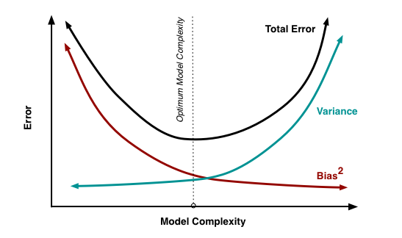

Bias, Variance trade-off:
The goal of any supervised machine learning algorithm is to have low bias and low variance to achieve good prediction performance.
- The k-nearest neighbor’s algorithm has low bias and high variance, but the trade-off can be changed by increasing the value of k which increases the number of neighbors that contribute to the prediction and in turn increases the bias of the model.
- The support vector machine algorithm has low bias and high variance, but the trade-off can be changed by increasing the C parameter that influences the number of violations of the margin allowed in the training data which increases the bias but decreases the variance.
There is no escaping the relationship between bias and variance in machine learning.
Increasing the bias will decrease the variance. Increasing the variance will decrease bias.

5. Differentiate between univariate, bivariate and multivariate analysis.
These are descriptive statistical analysis techniques which can be differentiated based on the number of variables involved at a given point of time. For example, the pie charts of sales based on territory involve only one variable and can be referred to as univariate analysis.
If the analysis attempts to understand the difference between 2 variables at the time as in a scatterplot, then it is referred to as bivariate analysis. For example, analysing the volume of sales and spending can be considered as an example of bivariate analysis.
Analysis that deals with the study of more than two variables to understand the effect of variables on the responses is referred to as multivariate analysis.

6. What are Recommender Systems?
A subclass of information filtering systems that are meant to predict the preferences or ratings that a user would give to a product. Recommender systems are widely used in movies, news, research articles, products, social tags, music, etc.

7. What is exploding gradients?
“Exploding gradients are a problem where large error gradients accumulate and result in very large updates to neural network model weights during training.” At an extreme, the values of weights can become so large as to overflow and result in NaN values.
This has the effect of your model being unstable and unable to learn from your training data. Now let’s understand what is the gradient.

Gradient:
Gradient is the direction and magnitude calculated during the training of a neural network that is used to update the network weights in the right direction and by the right amount.

8. What is logistic regression? Or State an example when you have used logistic regression recently.
Logistic Regression often referred to as the logit model is a technique to predict the binary outcome from a linear combination of predictor variables. For example, if you want to predict whether a particular political leader will win the election or not. In this case, the outcome of prediction is binary i.e. 0 or 1 (Win/Lose). The predictor variables here would be the amount of money spent on election campaigning of a particular candidate, the amount of time spent in campaigning, etc.

9. What are the differences between over-fitting and under-fitting?
In statistics and machine learning, one of the most common tasks is to fit a model to a set of training data, so as to be able to make reliable predictions on general untrained data.
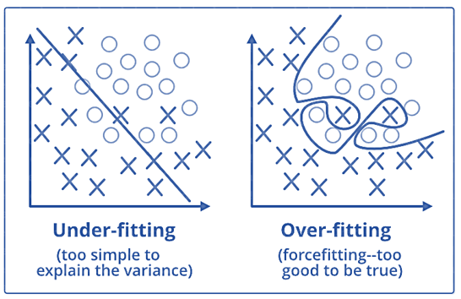
In overfitting, a statistical model describes random error or noise instead of the underlying relationship. Overfitting occurs when a model is excessively complex, such as having too many parameters relative to the number of observations. A model that has been overfitted, has poor predictive performance, as it overreacts to minor fluctuations in the training data.
Underfitting occurs when a statistical model or machine learning algorithm cannot capture the underlying trend of the data. Underfitting would occur, for example, when fitting a linear model to non-linear data. Such a model too would have poor predictive performance.

Products from Amazon.in
- 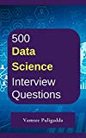
500 Most Important Data Science Interview Questions and Answers: Crack That Next Interview With Higher Salary In Less Preparation Time
Price: Check on Amazon
- 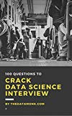
100 Questions to Crack Data Science Interview
Price: Check on Amazon
- 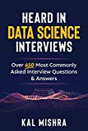-2%
Heard In Data Science Interviews: Over 650 Most Commonly Asked Interview Questions & Answers
Price: INR 3,573.00

Was: INR 3,638.00

- 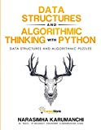-23%
Data Structure and Algorithmic Thinking with Python
Price: INR 498.00

Was: INR 650.00

- 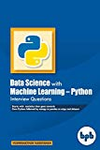-10%
Data Science with Machine Learning – Python Interview Questions
Price: INR 224.00

Was: INR 249.00

- 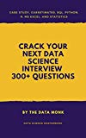
Crack Your Next Data Science Interview with 300+ Questions: SQL,Statistics,Python,R,Aptitude,Project Description
Price: Check on Amazon
- 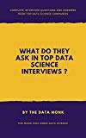
What do they ask in top Data Science Interviews: 5 Complete Data Science Real Interviews Q and A
Price: Check on Amazon
- 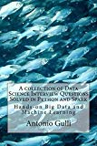
A collection of Data Science Interview Questions Solved in Python and Spark: BigData and Machine Learning in Python and Spark (A Collection of Programming Interview Questions Book 6)
Price: Check on Amazon
- 
100 Puzzles and Case Studies To Crack Data Science Interview
Price: Check on Amazon
‹›

10. How to combat Overfitting and Underfitting?
To combat overfitting and underfitting, you can resample the data to estimate the model accuracy (k-fold cross-validation) and by having a validation dataset to evaluate the model.

11. What are the different kernel’s functions in SVM?
There are four types of kernels in SVM.
- Linear Kernel
- Polynomial kernel
- Radial basis kernel
- Sigmoid kernel

12. Explain Decision Tree algorithm in detail.
Decision tree is a supervised machine learning algorithm mainly used for the Regression and Classification.It breaks down a dataset into smaller and smaller subsets while at the same time an associated decision tree is incrementally developed. The final result is a tree with decision nodes and leaf nodes. Decision tree can handle both categorical and numerical data.
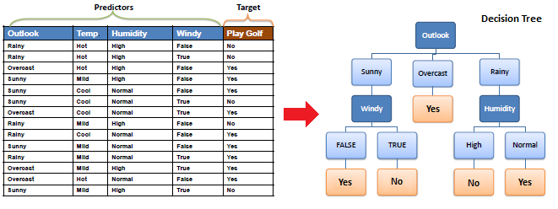

13. What is Entropy and Information gain in Decision tree algorithm?
The core algorithm for building decision tree is called ID3. ID3 uses Enteropy and Information Gain to construct a decision tree.
Entropy
A decision tree is built top-down from a root node and involve partitioning of data into homogenious subsets. ID3 uses enteropy to check the homogeneity of a sample. If the sample is completely homogenious then entropy is zero and if the sample is an equally divided it has entropy of one.
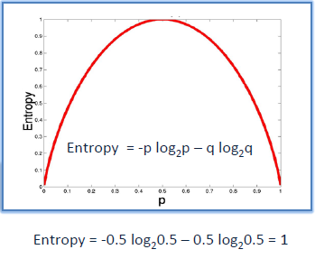
Information Gain
The Information Gain is based on the decrease in entropy after a dataset is split on an attribute. Constructing a decision tree is all about finding attributes that returns the highest information gain.
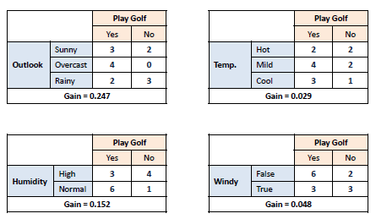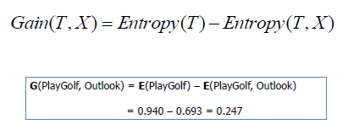

14. What is pruning in Decision Tree ?
When we remove sub-nodes of a decision node, this procsss is called pruning or opposite process of splitting.

15. What is Ensemble Learning ?
Ensemble is the art of combining diverse set of learners(Individual models) togather to improvise on the stability and predictive power of the model. Ensemble learning has many types but two more popular ensemble learning techniques are mentioned below.
Bagging
Bagging tries to implement similar learners on small sample populations and then takes a mean of all the predictions. In generalized bagging, you can use different learners on different population. As you expect this helps us to reduce the variance error.
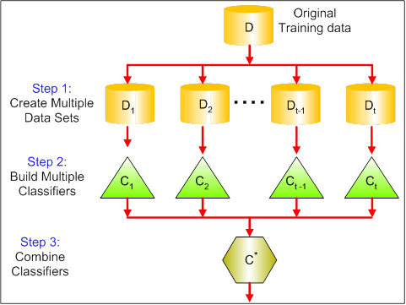
Boosting
Boosting is an iterative technique which adjust the weight of an observation based on the last classification. If an observation was classfied incorrectly, it tries to increase the weight of this observation and vice versa. Boosting in general decreases the bias error and builds strong predictive models. However, they may overfit on the training data.
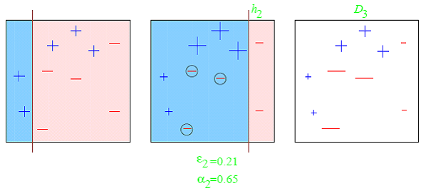

15. What is regularisation? Why is it useful?
Regularisation is the process of adding tuning parameter to a model to induce smoothness in order to prevent overfitting. This is most often done by adding a constant multiple to an existing weight vector. This constant is often the L1(Lasso) or L2(ridge). The model predictions should then minimize the loss function calculated on the regularized training set.

16. What Are the Types of Biases That Can Occur During Sampling?
- Selection bias
- Under coverage bias
- Survivorship bias

17. What is Survivorship Bias?
It is the logical error of focusing aspects that support surviving some process and casually overlooking those that did not work because of their lack of prominence. This can lead to wrong conclusions in numerous different means.

18. What is selection Bias?
Selection bias occurs when the sample obtained is not representative of the population intended to be analysed.

19. What do you understand by the term Normal Distribution?
Data is usually distributed in different ways with a bias to the left or to the right or it can all be jumbled up. However, there are chances that data is distributed around a central value without any bias to the left or right and reaches normal distribution in the form of a bell-shaped curve. The random variables are distributed in the form of a symmetrical bell-shaped curve.
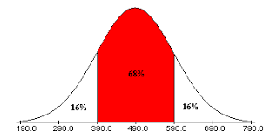

20. What is Random Forest? How does it work?
Random forest is a versatile machine learning method capable of performing both regression and classification tasks. It is also used for dimensionality reduction, treats missing values, outlier values. It is a type of ensemble learning method, where a group of weak models combines to form a powerful model.
In Random Forest, we grow multiple trees as opposed to a single tree. To classify a new object based on attributes, each tree gives a classification. The forest chooses the classification having the most votes(Overall the trees in the forest) and in case of regression, it takes the average of outputs by different trees.

21. What cross-validation technique would you use on a time series dataset?
Instead of using k-fold cross-validation, you should be aware to the fact that a time series is not randomly distributed data – It is inherently ordered by chronological order.
In case of time series data, you should use techniques like forward chaining – Where you will be model on past data then look at forward-facing data.
fold 1: training[1], test[2]
fold 1: training[1 2], test[3]
fold 1: training[1 2 3], test[4]
fold 1: training[1 2 3 4], test[5]

22. Explain how a ROC curve works?
The ROC curve is a graphical representation of the contrast between true positive rates and false-positive rates at various thresholds. It is often used as a proxy for the trade-off between the sensitivity(true positive rate) and false-positive rate.
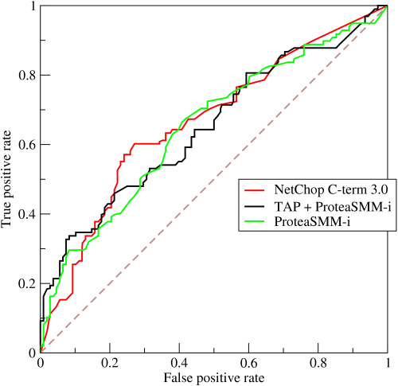

23. What is TF/IDF vectorization?
TF–IDF is short for term frequency-inverse document frequency, is a numerical statistic that is intended to reflect how important a word is to a document in a collection or corpus. It is often used as a weighting factor in information retrieval and text mining.
The TF–IDF value increases proportionally to the number of times a word appears in the document but is offset by the frequency of the word in the corpus, which helps to adjust for the fact that some words appear more frequently in general.

24. Are expected value and mean value different?
They are not different but the terms are used in different contexts. Mean is generally referred when talking about a probability distribution or sample population whereas expected value is generally referred in a random variable context.
For Sampling Data
Mean value is the only value that comes from the sampling data.
Expected Value is the mean of all the means i.e. the value that is built from multiple samples. The Expected value is the population mean.
For Distributions
The mean value and Expected value are the same irrespective of the distribution, under the condition that the distribution is in the same population.

25. What does P-value signify about the statistical data?
P-value is used to determine the significance of results after a hypothesis test in statistics. P-value helps the readers to draw conclusions and is always between 0 and 1.
• P- Value > 0.05 denotes weak evidence against the null hypothesis which means the null hypothesis cannot be rejected.
• P-value <= 0.05 denotes strong evidence against the null hypothesis which means the null hypothesis can be rejected.
• P-value=0.05is the marginal value indicating it is possible to go either way.

26. What is a Box-Cox Transformation?
Dependent variable for a regression analysis might not satisfy one or more assumptions of an ordinary least squares regression. The residuals could either curve as the prediction increases or follow skewed distribution. In such scenarios, it is necessary to transform the response variable so that the data meets the required assumptions. A Box cox transformation is a statistical technique to transform non-normal dependent variables into a normal shape. If the given data is not normal then most of the statistical techniques assume normality. Applying a box cox transformation means that you can run a broader number of tests.
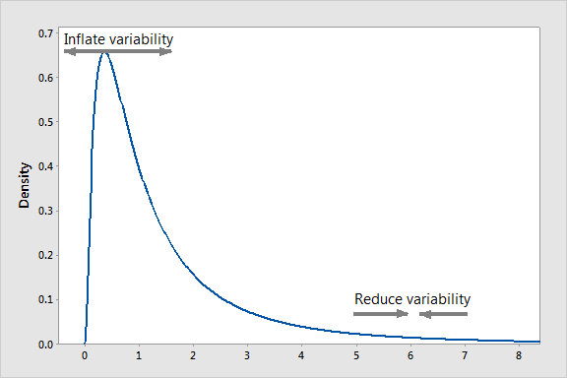
A Box Cox transformation is a way to transform non-normal dependent variables into a normal shape. Normality is an important assumption for many statistical techniques, if your data isn’t normal, applying a Box-Cox means that you are able to run a broader number of tests. The Box Cox transformation is named after statisticians George Box and Sir David Roxbee Cox who collaborated on a 1964 paper and developed the technique.

27. How will you define the number of clusters in a clustering algorithm?
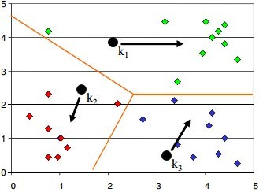
Though the Clustering Algorithm is not specified, this question will mostly be asked in reference to K-Means clustering where “K” defines the number of clusters. For example, the following image shows three different groups.
Within Sum of squares is generally used to explain the homogeneity within a cluster. If you plot WSS for a range of a number of clusters, you will get the plot shown below. The Graph is generally known as Elbow Curve.
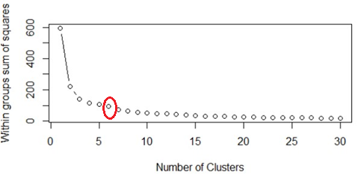
Red circled a point in the above graph i.e. Number of Cluster =6 is the point after which you don’t see any decrement in WSS. This point is known as bending point and taken as K in K – Means. This is the widely used approach but few data scientists also use Hierarchical clustering first to create dendrograms and identify the distinct groups from there.

28. Why we generally use Softmax non-linearity function as last operation in-network?
It is because it takes in a vector of real numbers and returns a probability distribution. Its definition is as follows. Let x be a vector of real numbers (positive, negative, whatever, there are no constraints).
Then the i’th component of Softmax(x) is —
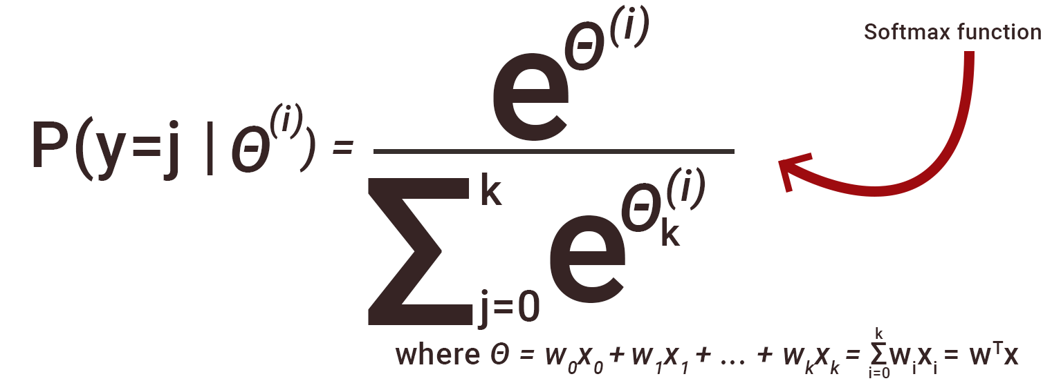
It should be clear that the output is a probability distribution: each element is non-negative and the sum over all components is 1.

29. What Is the Law of Large Numbers?
It is a theorem that describes the result of performing the same experiment a large number of times. This theorem forms the basis of frequency-style thinking. It says that the sample means, the sample variance and the sample standard deviation converge to what they are trying to estimate.

30. What Are Confounding Variables?
In statistics, a confounder is a variable that influences both the dependent variable and independent variable.
For example, if you are researching whether a lack of exercise leads to weight gain,
lack of exercise = independent variable
weight gain = dependent variable.
A confounding variable here would be any other variable that affects both of these variables, such as the age of the subject.

31. Do gradient descent methods always converge to same point?
No, they do not because in some cases it reaches a local minima or a local optima point. You don’t reach the global optima point. It depends on the data and starting conditions
32. A test has a true positive rate of 100% and a false-positive rate of 5%. There is a population with a 1/1000 rate of having the condition the test identifies. Considering a positive test, what is the probability of having that condition?
Let’s suppose you are being tested for a disease, if you have the illness the test will end up saying you have the illness. However, if you don’t have the illness- 5% of the time the test will end up saying you have the illness and 95% of the time the test will give accurate results that you don’t have the illness. Thus there is a 5% error in case you do not have the illness.
Out of 1000 people, 1 person who has the disease will get a true positive result.
Out of the remaining 999 people, 5% will also get a true positive result.
Close to 50 people will get a true positive result for the disease.
This means that out of 1000 people, 51 people will be tested positive for the disease even though only one person has the illness. There is only a 2% probability of you having the disease even if your reports say that you have the disease.

33. What is the goal of A/B Testing?
It is a statistical hypothesis testing for a randomized experiment with two variables A and B. The goal of A/B Testing is to identify any changes to the web page to maximize or increase the outcome of interest. An example of this could be identifying the click-through rate for a banner ad.

34. What are Eigenvalue and Eigenvector?
Eigenvectors are used for understanding linear transformations. In data analysis, we usually calculate the eigenvectors for a correlation or covariance matrix. Eigenvectors are the directions along which a particular linear transformation acts by flipping, compressing or stretching. Eigenvalue can be referred to as the strength of the transformation in the direction of eigenvector or the factor by which the compression occurs.

35. How can outlier values be treated?
Outlier values can be identified by using univariate or any other graphical analysis method. If the number of outlier values is few then they can be assessed individually but for a large number of outliers the values can be substituted with either the 99th or the 1st percentile values. All extreme values are not outlier values. The most common ways to treat outlier values
1) To change the value and bring in within a range
2) To just remove the value.

36. What is a confusion matrix?
The confusion matrix is a 2X2 table that contains 4 outputs provided by the binary classifier. Various measures, such as error-rate, accuracy, specificity, sensitivity, precision and recall are derived from it. Confusion Matrix
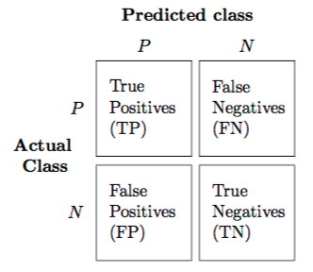
A dataset used for performance evaluation is called test dataset. It should contain the correct labels and predicted labels.
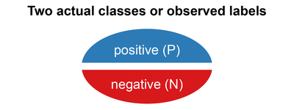
The predicted labels will exactly the same if the performance of a binary classfier is perfect.
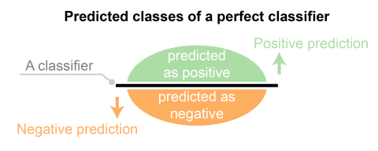
The predicted labels usually match with part of the observed labels in real world scenarios.
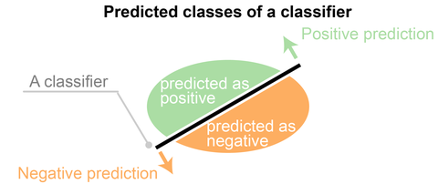
A binary classifier predicts all data instances of a test dataset as either positive or negative. This produces four outcomes-
- True positive(TP) – Correct positive prediction
- False positive(FP) – Incorrect positive prediction
- True negative(TN) – Correct negative prediction
- False negative(FN) – Incorrect negative prediction
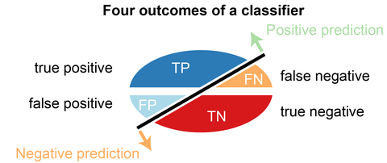
Basic measures derived from the confusion matrix
- Error Rate = (FP+FN)/(P+N)
- Accuracy = (TP+TN)/(P+N)
- Sensitivity(Recall or True positive rate) = TP/P
- Specificity(True negative rate) = TN/N
- Precision(Positive predicted value) = TP/(TP+FP)
- F-Score(Harmonic mean of precision and recall) = (1+b)(PREC.REC)/(b^2PREC+REC) where b is commonly 0.5, 1, 2.

36. Explain SVM machine learning algorithm in detail.
SVM stands for support vector machine, it is a supervised machine learning algorithm which can be used for both Regression and Classification. If you have n features in your training dataset, SVM tries to plot it in n-dimentional space with the value of each feature being the value of a particular coordinate. SVM uses hyper planes to seperate out different classes based on the provided kernel function.
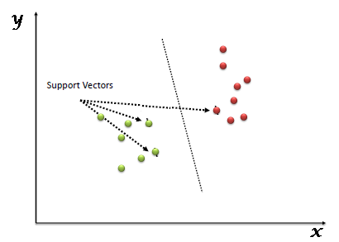

37. What are support vectors in SVM?
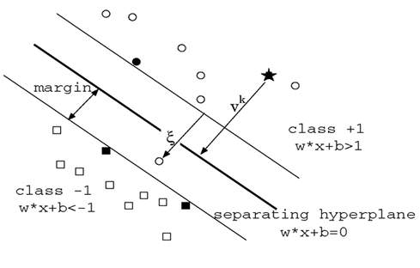
In the above diagram, we see that the thinner lines mark the distance from the classifier to the closest data points called the support vectors (darkened data points). The distance between the two thin lines is called the margin.

38. How can you assess a good logistic model?
There are various methods to assess the results of logistic regression analysis-
• Using Classification Matrix to look at the true negatives and false positives.
• Concordance helps identify the ability of the logistic model to differentiate between the event happening and not happening.
• Lift helps assess the logistic model by comparing it with random selection.

39. What are the various steps involved in an analytics project?
• Understand the business problem
• Explore the data and become familiar with it.
• Prepare the data for modeling by detecting outliers, treating missing values, transforming variables, etc.
• After data preparation, start running the model, analyse the result and tweak the approach. This is an iterative step until the best possible outcome is achieved.
• Validate the model using a new data set.
• Start implementing the model and track the result to analyse the performance of the model over the period of time.

40. How can you iterate over a list and also retrieve element indices at the same time?
This can be done using the enumerate function which takes every element in a sequence just like in a list and adds its location just before it.

41. During analysis, how do you treat missing values?
The extent of the missing values is identified after identifying the variables with missing values. If any patterns are identified the analyst has to concentrate on them as it could lead to interesting and meaningful business insights. If there are no patterns identified, then the missing values can be substituted with mean or median values (imputation) or they can simply be ignored.There are various factors to be considered when answering this question-
- Understand the problem statement, understand the data and then give the answer.Assigning a default value which can be mean, minimum or maximum value. Getting into the data is important.
- If it is a categorical variable, the default value is assigned. The missing value is assigned a default value.
- If you have a distribution of data coming, for normal distribution give the mean value.
- Should we even treat missing values is another important point to consider? If 80% of the values for a variable are missing then you can answer that you would be dropping the variable instead of treating the missing values.

42) Explain about the box cox transformation in regression models.
For some reason or the other, the response variable for a regression analysis might not satisfy one or more assumptions of an ordinary least squares regression. The residuals could either curve as the prediction increases or follow the skewed distribution. In such scenarios, it is necessary to transform the response variable so that the data meets the required assumptions. A Box cox transformation is a statistical technique to transform non-normal dependent variables into a normal shape. If the given data is not normal then most of the statistical techniques assume normality. Applying a box cox transformation means that you can run a broader number of tests.

43. What are Recurrent Neural Networks(RNNs) ?
Recurrent nets are a type of artificial neural network designed to recognize the pattern from the sequence of data such as Time series, stock market, and government agencies, etc. To understand recurrent nets, first, you have to understand the basics of feedforward nets. Both these networks RNN and feedforward named after the way they channel information through a series of mathematical operations performed at the nodes of the network. One feeds information through straight(never touching the same node twice), while the other cycles it through a loop, and the latter is called recurrent.
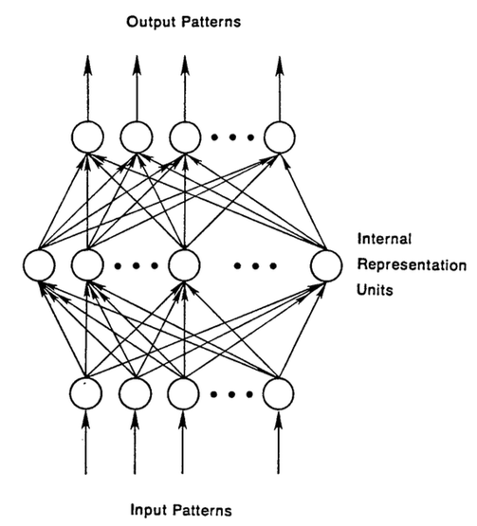
Recurrent networks on the other hand, take as their input not just the current input example they see, but also the what they have percieved previously in time. The BTSXPE at the bottom of the drawing represents the input example in the current moment, and CONTEXT UNIT represents the output of the previous moment. The decision a recurrent neural network reached at time t-1 affects the decision that it will reach one moment later at time t. So recurrent networks have two sources of input, the present and the recent past, which combine to determine how they respond to new data, much as we do in life.
The error they generate will return via backpropagation and be used to adjust their weights until error can’t go any lower. Remember, the purpose of recurrent nets is to accurately classify sequential input. We rely on the backpropagation of error and gradient descent to do so.
Backpropagation in feedforward networks moves backward from the final error through the outputs, weights and inputs of each hidden layer, assigning those weights responsibility for a portion of the error by calculating their partial derivatives – ∂E/∂w, or the relationship between their rates of change. Those derivatives are then used by our learning rule, gradient descent, to adjust the weights up or down, whichever direction decreases error.
Recurrent networks rely on an extension of backpropagation called backpropagation through time, or BPTT. Time, in this case, is simply expressed by a well-defined, ordered series of calculations linking one time step to the next, which is all backpropagation needs to work.
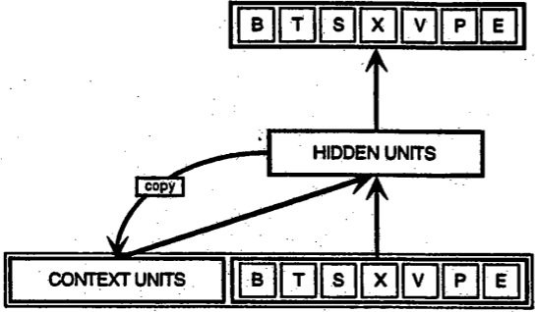

44. What is the difference between machine learning and deep learning?

Machine learning:
Machine learning is a field of computer science that gives computers the ability to learn without being explicitly programmed. Machine learning can be categorized in the following three categories.
- Supervised machine learning,
- Unsupervised machine learning,
- Reinforcement learning

Deep learning:
Deep Learning is a subfield of machine learning concerned with algorithms inspired by the structure and function of the brain called artificial neural networks.

45. What is reinforcement learning?
Reinforcement learning
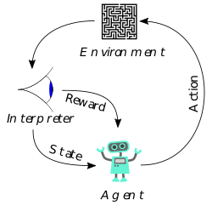
Reinforcement Learning is learning what to do and how to map situations to actions. The end result is to maximize the numerical reward signal. The learner is not told which action to take but instead must discover which action will yield the maximum reward. Reinforcement learning is inspired by the learning of human beings, it is based on the reward/penalty mechanism.

46. What is the difference between Bayesian Estimate and Maximum Likelihood Estimation (MLE)?
In bayesian estimate we have some knowledge about the data/problem (prior) .There may be several values of the parameters which explain data and hence we can look for multiple parameters like 5 gammas and 5 lambdas that do this. As a result of Bayesian Estimate, we get multiple models for making multiple predcitions i.e. one for each pair of parameters but with the same prior. So, if a new example need to be predicted than computing the weighted sum of these predictions serves the purpose.
Maximum likelihood does not take prior into consideration (ignores the prior) so it is like being a Bayesian while using some kind of a flat prior.

47. Explain Star Schema.
It is a traditional database schema with a central table. Satellite tables map IDs to physical names or descriptions and can be connected to the central fact table using the ID fields; these tables are known as lookup tables and are principally useful in real-time applications, as they save a lot of memory. Sometimes star schemas involve several layers of summarization to recover information faster.

48. What is Cluster Sampling?
Cluster sampling is a technique used when it becomes difficult to study the target population spread across a wide area and simple random sampling cannot be applied. Cluster Sample is a probability sample where each sampling unit is a collection or cluster of elements.
For eg., A researcher wants to survey the academic performance of high school students in Japan. He can divide the entire population of Japan into different clusters (cities). Then the researcher selects a number of clusters depending on his research through simple or systematic random sampling.
Let’s continue our Data Science Interview Questions blog with some more statistics questions.

Products from Amazon.in
500 Most Important Data Science Interview Questions and Answers: Crack That Next Interview With Higher Salary In Less Preparation Time
Price: Check on Amazon
100 Questions to Crack Data Science Interview
Price: Check on Amazon
Crack Your Next Data Science Interview with 300+ Questions: SQL,Statistics,Python,R,Aptitude,Project Description
Price: Check on Amazon
100 Puzzles and Case Studies To Crack Data Science Interview
Price: Check on Amazon
What do they ask in top Data Science Interviews: 5 Complete Data Science Real Interviews Q and A
Price: Check on Amazon
A collection of Data Science Interview Questions Solved in Python and Spark: BigData and Machine Learning in Python and Spark (A Collection of Programming Interview Questions Book 6)
Price: Check on Amazon
- -10%
Data Science with Machine Learning – Python Interview Questions
Price: INR 224.00

Was: INR 249.00

- -2%
Heard In Data Science Interviews: Over 650 Most Commonly Asked Interview Questions & Answers
Price: INR 3,573.00

Was: INR 3,638.00

- -23%
Data Structure and Algorithmic Thinking with Python
Price: INR 498.00

Was: INR 650.00

‹›

50. What is Systematic Sampling?
Systematic sampling is a statistical technique where elements are selected from an ordered sampling frame. In systematic sampling, the list is progressed in a circular manner so once you reach the end of the list, it is progressed from the top again. The best example of systematic sampling is equal probability method.

51. Can you cite some examples where a false positive is important than a false negative?
Let us first understand what false positives and false negatives are.
- False Positives are the cases where you wrongly classified a non-event as an event a.k.a Type I error.
- False Negatives are the cases where you wrongly classify events as non-events, a.k.a Type II error.
Example 1: In the medical field, assume you have to give chemotherapy to patients. Assume a patient comes to that hospital and he is tested positive for cancer, based on the lab prediction but he actually doesn’t have cancer. This is a case of false positive. Here it is of utmost danger to start chemotherapy on this patient when he actually does not have cancer. In the absence of cancerous cell, chemotherapy will do certain damage to his normal healthy cells and might lead to severe diseases, even cancer.
Example 2: Let’s say an e-commerce company decided to give $1000 Gift voucher to the customers whom they assume to purchase at least $10,000 worth of items. They send free voucher mail directly to 100 customers without any minimum purchase condition because they assume to make at least 20% profit on sold items above $10,000. Now the issue is if we send the $1000 gift vouchers to customers who have not actually purchased anything but are marked as having made $10,000 worth of purchase.

52. Can you cite some examples where a false negative important than a false positive?
Example 1: Assume there is an airport ‘A’ which has received high-security threats and based on certain characteristics they identify whether a particular passenger can be a threat or not. Due to a shortage of staff, they decide to scan passengers being predicted as risk positives by their predictive model. What will happen if a true threat customer is being flagged as non-threat by airport model?
Example 2: What if Jury or judge decides to make a criminal go free?
Example 3: What if you rejected to marry a very good person based on your predictive model and you happen to meet him/her after a few years and realize that you had a false negative?

53. How can you perform logistic regression with Microsoft Excel?
It is possible to perform logistic regression with Microsoft Excel. There are two ways to do it using Excel.
a) One is to use Add-ins provided by many websites which we can use.
b) Second is to use fundamentals of logistic regression and use Excel’s computational power to build a logistic regression
But when this question is being asked in an interview, interviewer is not looking for a name of Add-ins rather a method using the base excel functionalities.
Let’s use a sample data to learn about logistic regression using Excel. (Example assumes that you are familiar with basic concepts of logistic regression)
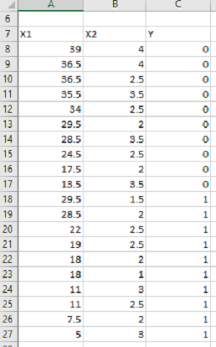
Data shown above consists of three variables where X1 and X2 are independent variables and Y is a class variable. We have kept only 2 categories for our purpose of binary logistic regression classifier.
Next we have to create a logit function using independent variables, i.e.
Logit = L = β₀ + β₁*X₁ + β₂*X₂
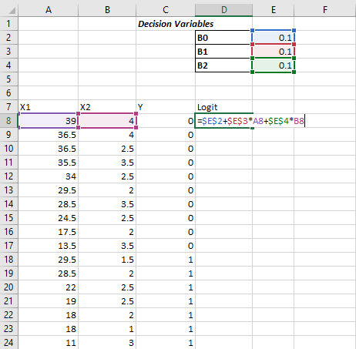
We have kept the initial values of beta 1, beta 2 as 0.1 for now and we will use Excel Solve to optimize the beta values in order to maximize our log likelihood estimate.
Assuming that you are aware of logistic regression basics, we calculate probability values from Logit using the following formula:
Probability= e^Logit/(1+ e^Logit )
e is base of natural logarithm i.e. e = 2.71828163
Let’s put it into excel formula to calculate probability values for each of the observation.
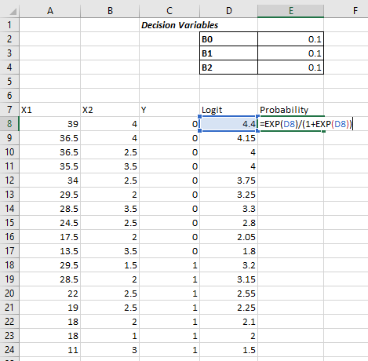
The conditional probability is the probability of Predicted Y, given a set of independent variables X.
And this p can be calculated as-
P(X)^Yactual*[1-P(X)^(1-Yactual)]
Then we have to take natural log of the above function-
ln⁡[ P(X)^Yactual*[1-P(X)^(1-Yactual) ]]
Which turns out to be
Yactual*ln⁡[ P(X)]*(Yactual- 1)*ln[1-P(X)]
Log-likelihood function LL is the sum of the above equation for all the observations
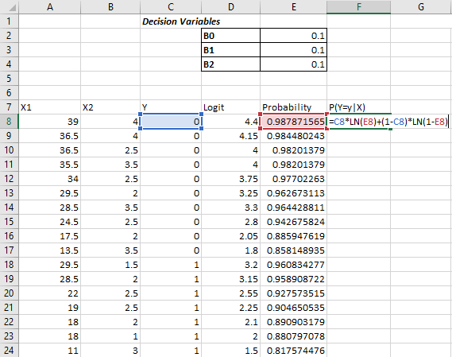
Log-likelihood LL will be the sum of column G, which we just calculated
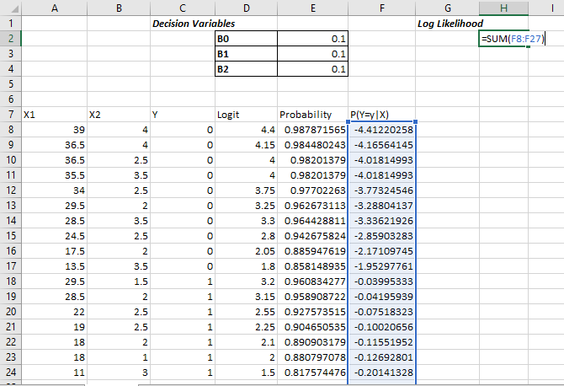
The objective is to maximize the Log Likelihood i.e. cell H2 in this example. We have to maximize H2 by optimizing B₀, B₁, and B_{2.}
We’ll use Excel’s solver add-in to achieve the same.
Excel comes with this Add-in pre-installed and you must see it under Data Tab in Excel as shown below
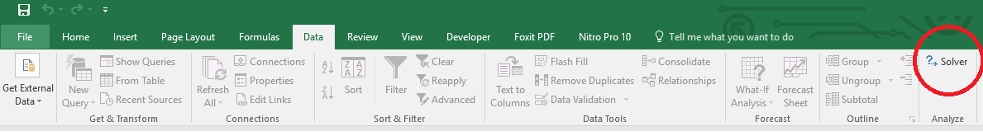
If you don’t see it there then make sure if you have loaded it. To load an add-in in Excel,
Go to File >> Options >> Add-Ins and see if checkbox in front of required add-in is checked or not? Make sure to check it to load an add-in into Excel.
If you don’t see Solver Add-in there, go to the bottom of the screen (Manage Add-Ins) and click on OK. Next you will see a popup window which should have your Solver add-in present. Check the checkbox in-front of the add-in name. If you don’t see it there as well click on browse and direct it to the required folder which contains Solver Add-In.
Once you have your Solver loaded, click on Solver icon under Data tab and You will see a new window popped up like –
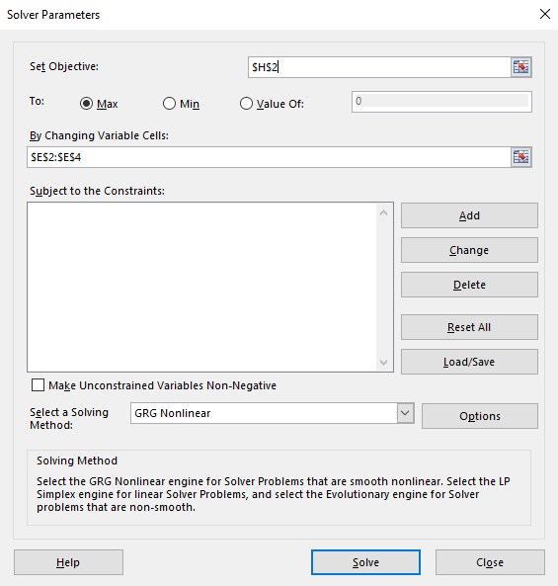
Put H2 in set objective, select max and fill cells E2 to E4 in next form field.
By doing this we have told Solver to Maximize H2 by changing values in cells E2 to E4.
Now click on Solve button at the bottom –
You will see a popup like below –
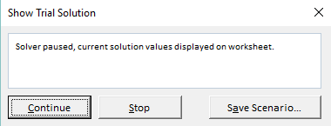
This shows that Solver has found a local maxima solution but we are in need of Global Maxima Output. Keep clicking on Continue until it shows the below popup
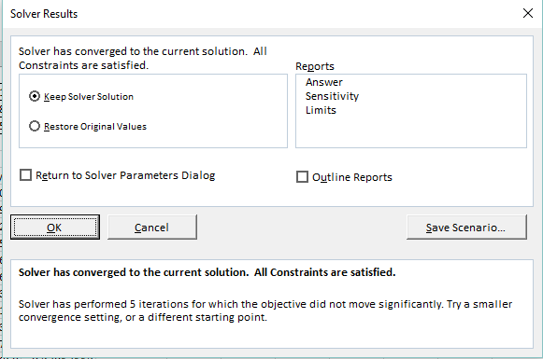
It shows that Solver was able to find and converge the solution. In case it is not able to converge it will throw an error. Select “Keep Solver Solution” and Click on OK to accept the solution provided by Solver.
Now, you can see that value of Beta coefficients from B_{0,} B₁ B₂ have changed and our Log Likelihood function has been maximized.
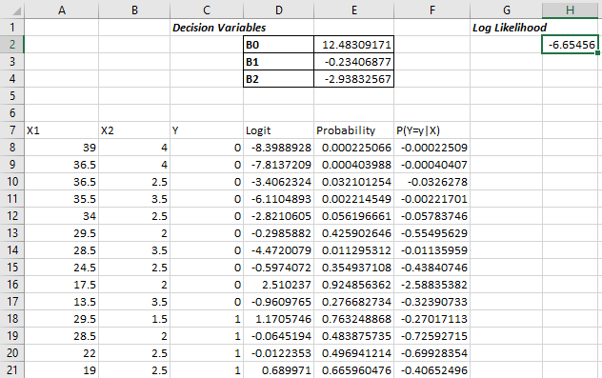
Using these values of Betas you can calculate the probability and hence response variable by deciding the probability cut-off.

54. What is the difference between skewed and uniform distribution?
When the observations in a dataset are spread equally across the range of distribution, then it is referred to as uniform distribution. There are no clear perks in a uniform distribution. Distributions that have more observations on one side of the graph than the other are referred to as skewed distribution. Distributions with fewer observations on the left ( towards lower values) are said to be skewed left and distributions with fewer observations on the right ( towards higher values) are said to be skewed right.

55. What is p-value?
When you perform a hypothesis test in statistics, a p-value can help you determine the strength of your results. A p-value is a number between 0 and 1. Based on the value it will denote the strength of the results. The claim which is on trial is called the Null Hypothesis.
Low p-value (≤ 0.05) indicates strength against the null hypothesis which means we can reject the null Hypothesis. High p-value (≥ 0.05) indicates strength for the null hypothesis which means we can accept the null Hypothesis p-value of 0.05 indicates the Hypothesis could go either way. To put it in another way,
High P values: your data are likely with a true null. Low P values: your data are unlikely with a true null.

56. What is ‘Naive’ in a Naive Bayes?
The Naive Bayes Algorithm is based on the Bayes Theorem. Bayes’ theorem describes the probability of an event, based on prior knowledge of conditions that might be related to the event.
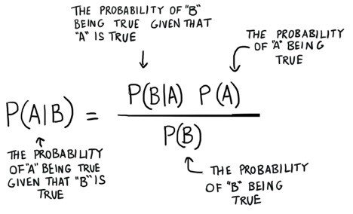

57. What is Naive?
The Algorithm is ‘naive’ because it makes assumptions that may or may not turn out to be correct.

58. If you are having 4GB RAM in your machine and you want to train your model on 10GB dataset. How would you go about this problem. Have you ever faced this kind of problem in your machine learning/data science experience so far ?
First of all you have to ask which ML model you want to train.
For Neural networks: Batch size with Numpy array will work.
Steps:
- Load the whole data in Numpy array. Numpy array has a property to create a mapping of a complete dataset, it doesn’t load the complete dataset in memory.
- You can pass an index to a Numpy array to get the required data.
- Use this data to pass to the Neural network.
- Have a small batch size.
For SVM: Partial fit will work
Steps:
- Divide one big dataset in small size datasets.
- Use a partial fit method of SVM, it requires a subset of the complete dataset.
- Repeat step 2 for other subsets.

59. Why L1 regularizations causes parameter sparsity whereas L2 regularization does not?
Regularizations in statistics or in the field of machine learning is used to include some extra information in order to solve a problem in a better way. L1 & L2 regularizations are generally used to add constraints to optimization problems.
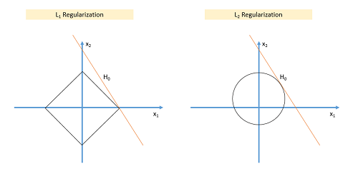
In the example shown above H₀ is a hypothesis. If you observe, in L₁ there is a high likelihood to hit the corners as solutions while in L₂, it doesn’t. So in L₁ variables are penalized more as compared to L2 which results in sparsity.
In other words, errors are squared in L₂, so the model sees a higher error and tries to minimize that squared error.

60. So what is differentiate between Data Science, Machine Learning and AI?
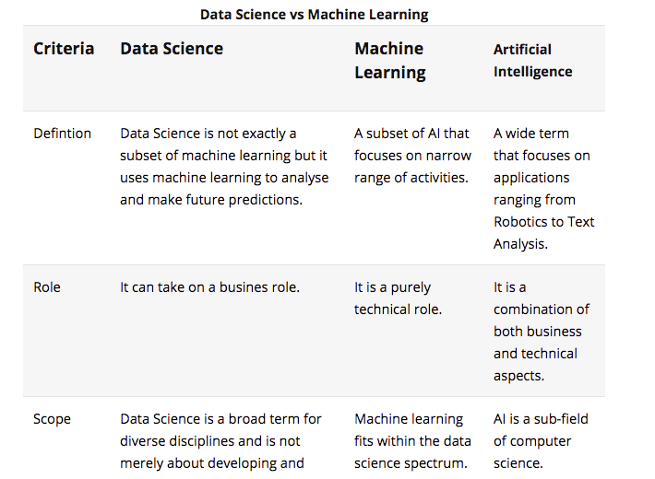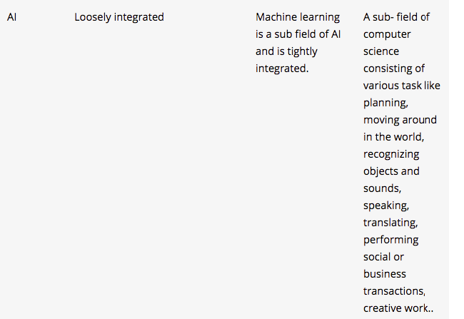

61. Can you explain the difference between a Validation Set and a Test Set?
A Validation set can be considered as a part of the training set as it is used for parameter selection and to avoid overfitting of the model being built.
On the other hand, a Test Set is used for testing or evaluating the performance of a trained machine learning model.
In simple terms, the differences can be summarized as; training set is to fit the parameters i.e. weights and test set is to assess the performance of the model i.e. evaluating the predictive power and generalization.

62. Explain cross-validation.
Cross-validation is a model validation technique for evaluating how the outcomes of statistical analysis will generalize to an independent dataset. Mainly used in backgrounds where the objective is forecast and one wants to estimate how accurately a model will accomplish in practice.
The goal of cross-validation is to term a data set to test the model in the training phase (i.e. validation data set) in order to limit problems like overfitting and get an insight on how the model will generalize to an independent data set.

63. How do data management procedures like missing data handling make selection bias worse?
Missing value treatment is one of the primary tasks which a data scientist is supposed to do before starting data analysis. There are multiple methods for missing value treatment. If not done properly, it could potentially result in selection bias. Let see few missing value treatment examples and their impact on selection-
Complete Case Treatment: Complete case treatment is when you remove the entire row in data even if one value is missing. You could achieve a selection bias if your values are not missing at random and they have some pattern. Assume you are conducting a survey and few people didn’t specify their gender. Would you remove all those people? Can’t it tell a different story?
Available case analysis: Let say you are trying to calculate the correlation matrix for data so you might remove the missing values from variables that are needed for that particular correlation coefficient. In this case, your values will not be fully correct as they are coming from population sets.
Mean Substitution: In this method, missing values are replaced with the mean of other available values. This might make your distribution biased e.g., standard deviation, correlation and regression are mostly dependent on the mean value of variables.
Hence, various data management procedures might include selection bias in your data if not chosen correctly.

64. What is the difference between Regression and classification ML techniques?
Both Regression and classification machine learning techniques come under Supervised machine learning algorithms. In Supervised machine learning algorithm, we have to train the model using labeled data set, While training we have to explicitly provide the correct labels and algorithm tries to learn the pattern from input to output. If our labels are discrete values then it will a classification problem, e.g A, B, etc. but if our labels are continuous values then it will be a regression problem, e.g 1.23, 1.333, etc.

65. What do you mean by Deep Learning?
Deep Learning is nothing but a paradigm of machine learning which has shown incredible promise in recent years. This is because of the fact that Deep Learning shows a great analogy with the functioning of the human brain.

66. What is the difference between machine learning and deep learning?
Machine learning is a field of computer science that gives computers the ability to learn without being explicitly programmed. Machine learning can be categorised in the following three categories.
- Supervised machine learning,
- Unsupervised machine learning,
- Reinforcement learning
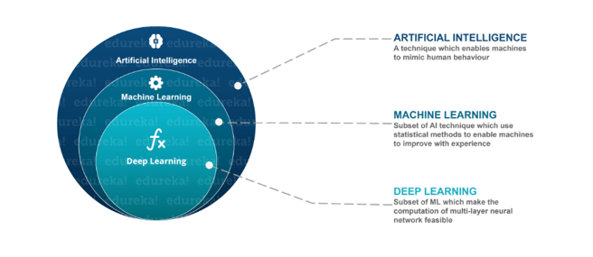
Deep Learning is a subfield of machine learning concerned with algorithms inspired by the structure and function of the brain called artificial neural networks.

67. What, in your opinion, is the reason for the popularity of Deep Learning in recent times?
Now although Deep Learning has been around for many years, the major breakthroughs from these techniques came just in recent years. This is because of two main reasons:
- The increase in the amount of data generated through various sources
- The growth in hardware resources required to run these models
GPUs are multiple times faster and they help us build bigger and deeper deep learning models in comparatively less time than we required previously.

68. What is reinforcement learning?
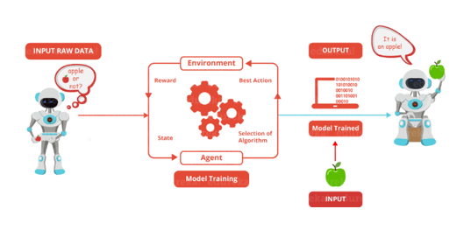
Reinforcement Learning is learning what to do and how to map situations to actions. The end result is to maximize the numerical reward signal. The learner is not told which action to take but instead must discover which action will yield the maximum reward. Reinforcement learning is inspired by the learning of human beings, it is based on the reward/penalty mechanism.

69. What are Artificial Neural Networks?
Artificial Neural networks are a specific set of algorithms that have revolutionized machine learning. They are inspired by biological neural networks. Neural Networks can adapt to changing the input so the network generates the best possible result without needing to redesign the output criteria.

70. Describe the structure of Artificial Neural Networks?
Artificial Neural Networks works on the same principle as a biological Neural Network. It consists of inputs that get processed with weighted sums and Bias, with the help of Activation Functions.
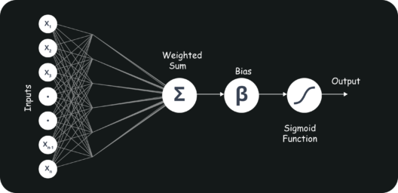

71. How Are Weights Initialized in a Network?
There are two methods here: we can either initialize the weights to zero or assign them randomly.
Initializing all weights to 0: This makes your model similar to a linear model. All the neurons and every layer perform the same operation, giving the same output and making the deep net useless.
Initializing all weights randomly: Here, the weights are assigned randomly by initializing them very close to 0. It gives better accuracy to the model since every neuron performs different computations. This is the most commonly used method.

71. What Is the Cost Function?
Also referred to as “loss” or “error,” cost function is a measure to evaluate how good your model’s performance is. It’s used to compute the error of the output layer during backpropagation. We push that error backward through the neural network and use that during the different training functions.
72. What Are Hyperparameters?
With neural networks, you’re usually working with hyperparameters once the data is formatted correctly. A hyperparameter is a parameter whose value is set before the learning process begins. It determines how a network is trained and the structure of the network (such as the number of hidden units, the learning rate, epochs, etc.).

73. What Will Happen If the Learning Rate Is Set inaccurately (Too Low or Too High)?
When your learning rate is too low, training of the model will progress very slowly as we are making minimal updates to the weights. It will take many updates before reaching the minimum point.
If the learning rate is set too high, this causes undesirable divergent behaviour to the loss function due to drastic updates in weights. It may fail to converge (model can give a good output) or even diverge (data is too chaotic for the network to train).

74. What Is the Difference Between Epoch, Batch, and Iteration in Deep Learning?
- Epoch – Represents one iteration over the entire dataset (everything put into the training model).
- Batch – Refers to when we cannot pass the entire dataset into the neural network at once, so we divide the dataset into several batches.
- Iteration – if we have 10,000 images as data and a batch size of 200. then an epoch should run 50 iterations (10,000 divided by 50).

75. What do you understand by Recall and Precision?
Recall measures “Of all the actual true samples how many did we classify as true?”
Precision measures “Of all the samples we classified as true how many are actually true?”
We will explain this with a simple example for better understanding –
Imagine that your wife gave you surprises every year on your anniversary in last 12 years. One day all of a sudden your wife asks -“Darling, do you remember all anniversary surprises from me?”.
This simple question puts your life into danger. To save your life, you need to Recall all 12 anniversary surprises from your memory. Thus, Recall(R) is the ratio of number of events you can correctly recall to the number of all correct events. If you can recall all the 12 surprises correctly then the recall ratio is 1 (100%) but if you can recall only 10 surprises correctly of the 12 then the recall ratio is 0.83 (83.3%).
However, you might be wrong in some cases. For instance, you answer 15 times, 10 times the surprises you guess are correct and 5 wrong. This implies that your recall ratio is 100% but the precision is 66.67%.
Precision is the ratio of number of events you can correctly recall to a number of all events you recall (combination of wrong and correct recalls).

76. Give some situations where you will use an SVM over a RandomForest Machine Learning algorithm and vice-versa.
SVM and Random Forest are both used in classification problems.
a) If you are sure that your data is outlier free and clean then go for SVM. It is the opposite – if your data might contain outliers then Random forest would be the best choice
b) Generally, SVM consumes more computational power than Random Forest, so if you are constrained with memory go for Random Forest machine learning algorithm.
c) Random Forest gives you a very good idea of variable importance in your data, so if you want to have variable importance then choose Random Forest machine learning algorithm.
d) Random Forest machine learning algorithms are preferred for multiclass problems.
e) SVM is preferred in multi-dimensional problem set – like text classification
but as a good data scientist, you should experiment with both of them and test for the accuracy or rather you can use an ensemble of many Machine Learning techniques.

77.What Are the Different Layers on CNN?
There are four layers in CNN:
- Convolutional Layer – the layer that performs a convolutional operation, creating several smaller picture windows to go over the data.
- ReLU Layer – it brings non-linearity to the network and converts all the negative pixels to zero. The output is a rectified feature map.
- Pooling Layer – pooling is a down-sampling operation that reduces the dimensionality of the feature map.
- Fully Connected Layer – this layer recognizes and classifies the objects in the image.

78. What Is Pooling on CNN, and How Does It Work?
Pooling is used to reduce the spatial dimensions of a CNN. It performs down-sampling operations to reduce the dimensionality and creates a pooled feature map by sliding a filter matrix over the input matrix.

79. What Is a Multi-layer Perceptron(MLP)?
As in Neural Networks, MLPs have an input layer, a hidden layer, and an output layer. It has the same structure as a single layer perceptron with one or more hidden layers. A single layer perceptron can classify only linear separable classes with binary output (0,1), but MLP can classify nonlinear classes.
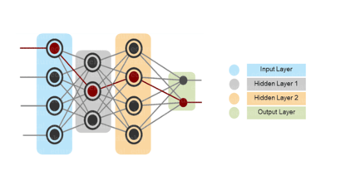
Except for the input layer, each node in the other layers uses a nonlinear activation function. This means the input layers, the data coming in, and the activation function is based upon all nodes and weights being added together, producing the output. MLP uses a supervised learning method called “backpropagation.” In backpropagation, the neural network calculates the error with the help of cost function. It propagates this error backward from where it came (adjusts the weights to train the model more accurately).

79. Explain Gradient Descent.
To Understand Gradient Descent, Let’s understand what is a Gradient first.
A gradient measures how much the output of a function changes if you change the inputs a little bit. It simply measures the change in all weights with regard to the change in error. You can also think of a gradient as the slope of a function.
Gradient Descent can be thought of climbing down to the bottom of a valley, instead of climbing up a hill. This is because it is a minimization algorithm that minimizes a given function (Activation Function).

80. What is exploding gradients?
While training an RNN, if you see exponentially growing (very large) error gradients which accumulate and result in very large updates to neural network model weights during training, they’re known as exploding gradients. At an extreme, the values of weights can become so large as to overflow and result in NaN values.
This has the effect of your model is unstable and unable to learn from your training data.

81. What is vanishing gradients?
While training an RNN, your slope can become either too small; this makes the training difficult. When the slope is too small, the problem is known as a Vanishing Gradient. It leads to long training times, poor performance, and low accuracy.

82. What is Back Propagation and Explain it’s Working.
Backpropagation is a training algorithm used for multilayer neural network. In this method, we move the error from an end of the network to all weights inside the network and thus allowing efficient computation of the gradient.
It has the following steps:
- Forward Propagation of Training Data
- Derivatives are computed using output and target
- Back Propagate for computing derivative of error wrt output activation
- Using previously calculated derivatives for output
- Update the Weights

83. What are the variants of Back Propagation?
- Stochastic Gradient Descent: We use only a single training example for calculation of gradient and update parameters.
- Batch Gradient Descent: We calculate the gradient for the whole dataset and perform the update at each iteration.
- Mini-batch Gradient Descent: It’s one of the most popular optimization algorithms. It’s a variant of Stochastic Gradient Descent and here instead of single training example, mini-batch of samples is used.

84. What are the different Deep Learning Frameworks?
- Pytorch
- TensorFlow
- Microsoft Cognitive Toolkit
- Keras
- Caffe
- Chainer

85. What is the role of the Activation Function?
The Activation function is used to introduce non-linearity into the neural network helping it to learn more complex function. Without which the neural network would be only able to learn linear function which is a linear combination of its input data. An activation function is a function in an artificial neuron that delivers an output based on inputs.

86 Name a few Machine Learning libraries for various purposes.
Purpose | Libraries
Scientific Computation | Numpy
Tabular Data | Pandas
Data Modelling & Preprocessing | Scikit Learn
Time-Series Analysis | Statsmodels
Text processing | Regular Expressions, NLTK
Deep Learning | Tensorflow, Pytorch

87. What is an Auto-Encoder?
Auto-encoders are simple learning networks that aim to transform inputs into outputs with the minimum possible error. This means that we want the output to be as close to input as possible. We add a couple of layers between the input and the output, and the sizes of these layers are smaller than the input layer. The auto-encoder receives unlabelled input which is then encoded to reconstruct the input.

89. What is a Boltzmann Machine?
Boltzmann machines have a simple learning algorithm that allows them to discover interesting features that represent complex regularities in the training data. The Boltzmann machine is basically used to optimise the weights and the quantity for the given problem. The learning algorithm is very slow in networks with many layers of feature detectors. “Restricted Boltzmann Machines” algorithm has a single layer of feature detectors which makes it faster than the rest.
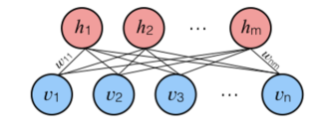

90. What Is Dropout and Batch Normalization?
Dropout is a technique of dropping out hidden and visible units of a network randomly to prevent overfitting of data (typically dropping 20 per cent of the nodes). It doubles the number of iterations needed to converge the network.
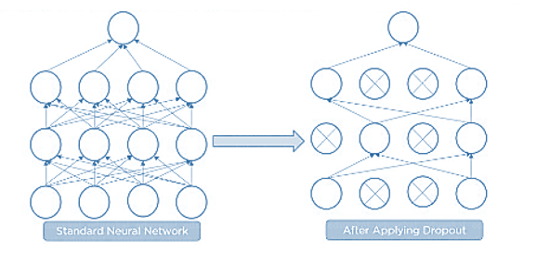
Batch normalization is the technique to improve the performance and stability of neural networks by normalizing the inputs in every layer so that they have mean output activation of zero and standard deviation of one.

91. What Is the Difference Between Batch Gradient Descent and Stochastic Gradient Descent?
Batch Gradient Descent | Stochastic Gradient Descent
The batch gradient computes the gradient using the entire dataset. | The stochastic gradient computes the gradient using a single sample.
It takes time to converge because the volume of data is huge, and weights update slowly. | It converges much faster than the batch gradient because it updates weight more frequently.

92. Why Is Tensorflow the Most Preferred Library in Deep Learning?
Tensorflow provides both C++ and Python APIs, making it easier to work on and has a faster compilation time compared to other Deep Learning libraries like Keras and Torch. Tensorflow supports both CPU and GPU computing devices.
Q99. What Do You Mean by Tensor in Tensorflow?
A tensor is a mathematical object represented as arrays of higher dimensions. These arrays of data with different dimensions and ranks fed as input to the neural network are called “Tensors.”

92. What is the Computational Graph?
Everything in a tensorflow is based on creating a computational graph. It has a network of nodes where each node operates, Nodes represent mathematical operations, and edges represent tensors. Since data flows in the form of a graph, it is also called a “DataFlow Graph.”

93. What is a Generative Adversarial Network?
Suppose there is a wine shop purchasing wine from dealers, which they resell later. But some dealers sell fake wine. In this case, the shop owner should be able to distinguish between fake and authentic wine.
The forger will try different techniques to sell fake wine and make sure specific techniques go past the shop owner’s check. The shop owner would probably get some feedback from wine experts that some of the wine is not original. The owner would have to improve how he determines whether a wine is fake or authentic.
The forger’s goal is to create wines that are indistinguishable from the authentic ones while the shop owner intends to tell if the wine is real or not accurately
Let us understand this example with the help of an image.
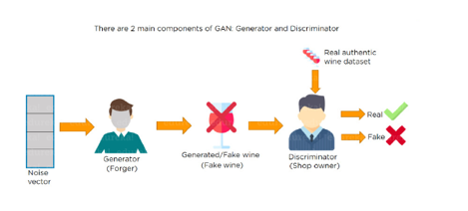
There is a noise vector coming into the forger who is generating fake wine.
Here the forger acts as a Generator.
The shop owner acts as a Discriminator.
The Discriminator gets two inputs; one is the fake wine, while the other is the real authentic wine. The shop owner has to figure out whether it is real or fake.
So, there are two primary components of Generative Adversarial Network (GAN) named:
- Generator
- Discriminator
The generator is a CNN that keeps keys producing images and is closer in appearance to the real images while the discriminator tries to determine the difference between real and fake images The ultimate aim is to make the discriminator learn to identify real and fake images.
Apart from the very technical questions, your interviewer could even hit you up with a few simple ones to check your overall confidence, in the likes of the following.

94. What are the important skills to have in Python with regard to data analysis?
The following are some of the important skills to possess which will come handy when performing data analysis using Python.
- Good understanding of the built-in data types especially lists, dictionaries, tuples, and sets.
- Mastery of N-dimensional NumPy Arrays.
- Mastery of Pandas data frames.
- Ability to perform element-wise vector and matrix operations on NumPy arrays.
- Knowing that you should use the Anaconda distribution and the conda package manager.
- Familiarity with Scikit-learn.
- Ability to write efficient list comprehensions instead of traditional for loops.
- Ability to write small, clean functions (important for any developer), preferably pure functions that don’t alter objects.
- Knowing how to profile the performance of a Python script and how to optimize bottlenecks.

PYTHON SPECIFIC

95. Which library would you prefer for plotting in Python language: Seaborn or Matplotlib?
Matplotlib is the python library used for plotting but it needs lot of fine-tuning to ensure that the plots look shiny. Seaborn helps data scientists create statistically and aesthetically appealing meaningful plots. The answer to this question varies based on the requirements for plotting data

96. Which method in pandas.tools.plotting is used to create scatter plot matrix?
Scatter_matrix

97. How can you check if a data set or time series is Random?
To check whether a dataset is random or not use the lag plot. If the lag plot for the given dataset does not show any structure then it is random.

98. What are the possible ways to load an array from a text data file in Python? How can the efficiency of the code to load datafile be improved?
numpy.loadtxt ()

99. Name a few libraries in Python used for Data Analysis and Scientific computations.
NumPy, SciPy, Pandas, SciKit, Matplotlib, Seaborn

Products from Amazon.in
500 Most Important Data Science Interview Questions and Answers: Crack That Next Interview With Higher Salary In Less Preparation Time
Price: Check on Amazon
100 Questions to Crack Data Science Interview
Price: Check on Amazon
What do they ask in top Data Science Interviews: 5 Complete Data Science Real Interviews Q and A
Price: Check on Amazon
- -10%
Data Science with Machine Learning – Python Interview Questions
Price: INR 224.00

Was: INR 249.00

100 Puzzles and Case Studies To Crack Data Science Interview
Price: Check on Amazon
- -2%
Heard In Data Science Interviews: Over 650 Most Commonly Asked Interview Questions & Answers
Price: INR 3,573.00

Was: INR 3,638.00

- -23%
Data Structure and Algorithmic Thinking with Python
Price: INR 498.00

Was: INR 650.00

A collection of Data Science Interview Questions Solved in Python and Spark: BigData and Machine Learning in Python and Spark (A Collection of Programming Interview Questions Book 6)
Price: Check on Amazon
Crack Your Next Data Science Interview with 300+ Questions: SQL,Statistics,Python,R,Aptitude,Project Description
Price: Check on Amazon
‹›

100 Write the code to sort an array in NumPy by the nth column?
Using argsort () function this can be achieved. If there is an array X and you would like to sort the nth column then code for this will be x[x [: n-1].argsort ()]

101. What is pylab?
A package that combines NumPy, SciPy and Matplotlib into a single namespace.

102. Which python library is built on top of matplotlib and Pandas to ease data plotting?
Seaborn

103. Which plot will you use to access the uncertainty of a statistic?
Bootstrap

104. What is PEP8?
PEP8 consists of coding guidelines for Python language so that programmers can write readable code making it easy to use for any other person, later on.

105. Is all the memory freed when Python exits?
No, it is not, because the objects that are referenced from global namespaces of Python modules are not always de-allocated when Python exits.

106. What does _init_.py do?
_init_.py is an empty py file used for importing a module in a directory. _init_.py provides an easy way to organize the files. If there is a module maindir/subdir/module.py,_init_.py is placed in all the directories so that the module can be imported using the following command-
import maindir.subdir.module

107. What is the difference between tuples and lists in Python?
Tuples can be used as keys for dictionaries i.e. they can be hashed. Lists are mutable whereas tuples are immutable – they cannot be changed. Tuples should be used when the order of elements in a sequence matters. For example, set of actions that need to be executed in sequence, geographic locations or list of points on a specific route.
108. How can you copy objects in Python?
The functions used to copy objects in Python are-
1) Copy.copy () for shallow copy
2) Copy.deepcopy () for deep copy
However, it is not possible to copy all objects in Python using these functions. For instance, dictionaries have a separate copy method whereas sequences in Python have to be copied by ‘Slicing’.

109. What is the difference between range () and xrange () functions in Python?
range () returns a list whereas xrange () returns an object that acts like an iterator for generating numbers on demand.

110. How can you randomize the items of a list in place in Python?
Shuffle (lst) can be used for randomizing the items of a list in Python

111. Explain the usage of decorators.
Decorators in Python are used to modify or inject code in functions or classes. Using decorators, you can wrap a class or function method call so that a piece of code can be executed before or after the execution of the original code. Decorators can be used to check for permissions, modify or track the arguments passed to a method, logging the calls to a specific method, etc.

112. What is the difference between Data Mining and Data Analysis?
Data Mining | Data Analysis
Data mining usually does not require any hypothesis. | Data analysis begins with a question or an assumption.
Data Mining depends on clean and well-documented data. | Data analysis involves data cleaning.
Results of data mining are not always easy to interpret. | Data analysts interpret the results and convey the to the stakeholders.
Data mining algorithms automatically develop equations. | Data analysts have to develop their own equations based on the hypothesis.

113. Explain the typical data analysis process.
Data analysis deals with collecting, inspecting, cleansing, transforming and modelling data to glean valuable insights and support better decision making in an organization. The various steps involved in the data analysis process include
Data Exploration
Having identified the business problem, a data analyst has to go through the data provided by the client to analyse the root cause of the problem.
Data Preparation
This is the most crucial step of the data analysis process wherein any data anomalies (like missing values or detecting outliers) with the data have to be modelled in the right direction.
Data Modelling
The modelling step begins once the data has been prepared. Modelling is an iterative process wherein the model is run repeatedly for improvements. Data modelling ensures that the best possible result is found for a given business problem.
Validation
In this step, the model provided by the client and the model developed by the data analyst are validated against each other to find out if the developed model will meet the business requirements.
Implementation of the Model and Tracking
This is the final step of the data analysis process wherein the model is implemented in production and is tested for accuracy and efficiency.

114. How will you handle the QA process when developing a predictive model to forecast customer churn?
Data analysts require inputs from the business owners and a collaborative environment to operationalize analytics. To create and deploy predictive models in production there should be an effective, efficient and repeatable process. Without taking feedback from the business owner, the model will just be a one-and-done model.
The best way to answer this question would be to say that you would first partition the data into 3 different sets Training, Testing and Validation. You would then show the results of the validation set to the business owner by eliminating biases from the first 2 sets. The input from the business owner or the client will give you an idea of whether your model predicts customer churn with accuracy and provides desired results.

115. How often should you retrain a data model?
A good data analyst is the one who understands how changing business dynamics will affect the efficiency of a predictive model. You must be a valuable consultant who can use analytical skills and business acumen to find the root cause of business problems.
The best way to answer this question would be to say that you would work with the client to define a time period in advance. However, I would refresh or retrain a model when the company enters a new market, consummate an acquisition or is facing emerging competition. As a data analyst, I would retrain the model as quickly as possible to adjust to the changing behavior of customers or change in market conditions.

116. What are the criteria to say whether a developed data model is good or not?
- The developed model should have predictable performance.
- A good data model can adapt easily to any changes in business requirements.
- Any major data changes in a good data model should be scalable.
- A good data model is one that can be easily consumed for actionable results.

117. According to you what are the qualities/skills that a data analyst must possess to be successful at this position?
Problem Solving and Analytical thinking are the two important skills to be successful as a data analyst. One needs to skilled ar formatting data so that the gleaned information is available in an easy-to-read manner. Not to forget technical proficiency is of significant importance. You can also talk about other skills that the interviewer expects in an ideal candidate for the job position based on the given job description.

118. What do you know about interquartile range as a data analyst?
A measure of the dispersion of data that is shown in a box plot is referred to as the interquartile range. It is the difference between the upper and the lower quartile.

R SPECIFIC

119. How many data structures does the R language have?
R language has Homogeneous and Heterogeneous data structures. Homogeneous data structures have the same type of objects – Vector, Matrix ad Array. Heterogeneous data structures have a different type of objects – Data frames and lists.

120. What is the process to create a table in R language without using external files?
MyTable= data.frame ()
edit (MyTable)
The above code will open an Excel Spreadsheet for entering data into MyTable

130. What is the difference between data frame and a matrix in R?
Data frame can contain heterogeneous inputs while a matrix cannot. In matrix only similar data types can be stored whereas in a data frame there can be different data types like characters, integers or other data frames.

131. How can you add datasets in R?
rbind () function can be used to add datasets in R language provided the columns in the datasets should be the same.

132. R programming language has several packages for data science which are meant to solve a specific problem, how do you decide which one to use?
CRAN package repository in R has more than 6000 packages, so a data scientist needs to follow a well-defined process and criteria to select the right one for a specific task. When looking for a package in the CRAN repository a data scientist should list out all the requirements and issues so that an ideal R package can address all those needs and issues.
The best way to answer this question is to look for an R package that follows good software development principles and practices. For example, you might want to look at the quality documentation and unit tests. The next step is to check out how a particular R package is used and read the reviews posted by other users of the R package. It is important to know if other data scientists or data analysts have been able to solve a similar problem as that of yours. When you in doubt choosing a particular R package, I would always ask for feedback from R community members or other colleagues to ensure that I am making the right choice.

133. How can you merge two data frames in R language?
Data frames in R language can be merged manually using cbind () functions or by using the merge () function on common rows or columns.

134. What is power analysis?
Power analysis is the process used to determine the effect of a given sample size and is generally used for experimental design. Pwr package in R is used for power analysis.

135. How can you load a .csv file in R?
- Loading a .csv file in R is quite easy.
- All you need to do is use the “read.csv()” function and specify the path of the file.
house<-read.csv("C:/Users/John/Desktop/house.csv")

136. What are the different components of grammar of graphics?
Broadly speaking these are different components in grammar of graphics:
- Data layer
- Aesthetics layer
- Geometry layer
- Facet layer
- Co-ordinate layer
- Themes layer

137. What is Rmarkdown? What is the use of it?
RMarkdown is a reporting tool provided by R. With the help of Rmarkdown, you can create high-quality reports of your R code.
The output format of Rmarkdown can be:
- HTML
- PDF
- WORD
. Name some packages in R, which can be used for data imputation?
These are some packages in R which can used for data imputation
- MICE
- Amelia
- missForest
- Hmisc
- Mi
- imputeR
138. Explain about confusion matrix in R?
A confusion matrix can be used to evaluate the accuracy of the model built. It Calculates a cross-tabulation of observed and predicted classes. This can be done using the “confusionmatrix()” function from the “caTools” package.
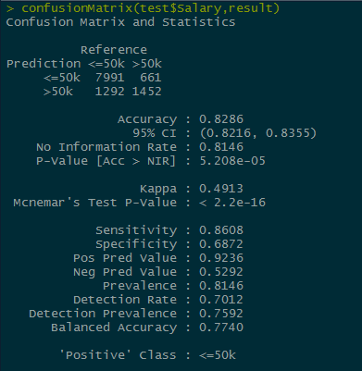
Here, we have created a confusion matrix, which gives a tabulated list for “actual” and “predicted” values.
139. How would you write a custom function in R? Give an example.
This is the syntax to write a custom function In R:
<object-name>=function(x){
—
—
}
Let’s look at an example to create a custom function in R ->
fun1<-function(x){ ifelse(x>5,100,0) }
v<-c(1,2,3,4,5,6,7,8,9,10)
fun1(v)->v

140. Tell me something about shinyR.
Shiny is an R package that makes it easy to build interactive web apps straight from R. You can host standalone apps on a webpage or embed them in Rmarkdown documents or build dashboards. You can also extend your Shiny apps with CSS themes, HTML widgets, and JavaScript actions.

141. What is a Random Walk model and how can you simulate it using R?
A random walk is a simple example of non-stationary process.
A random walk has:
- No specified mean or variance
- Strong dependence over time
- It’s changes or increments are white noise
Simulating random walk in R:
arima.sim(model=list(order=c(0,1,0)),n=50)->rw ts.plot(rw)
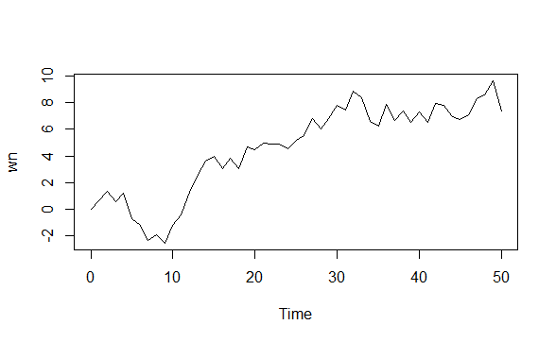

142. What is Principal Component Analysis and how can you create a PCA model in R?
Principal Component Analysis is a method for dimensionality reduction. Many a times, it happens that, one observation is related to multiple dimensions(features) and this brings in a lot of chaos to the data, that is why it is important to reduce the number of dimensions.
The concept of Principal Component Analysis is this:
- The data is transformed to a new space, with equal or less number of dimensions. These dimensions(features) are known as principal components.
- The first principal component captures the maximum amount of variance from the features in the original data.
- The second principal component is orthogonal to the first and captures the maximum amount of variability left.
- The same is true for each principal component, they are all uncorrelated and each is less important than the previous one.
We can do PCA in R with the help of “prcomp()” function.
prcomp(iris[-5])->pca
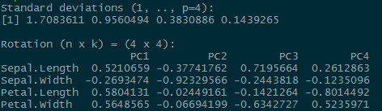
Let’s see how thee variability decreases across different principal components
screeplot(pca)
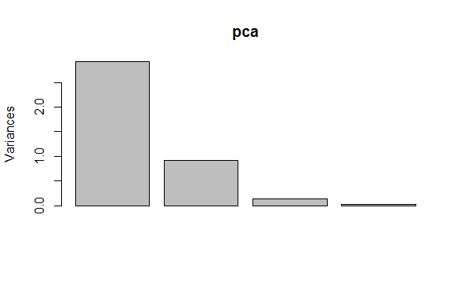

143. How would you build a Scatter-plot using plotly?
With the help of “plotly” we can create stunning visualizations.
This is the command to create a stunning scatter plot with the help of “plotly” package.
plot_ly(house,y=~price,x=~living_area,color=~rooms)
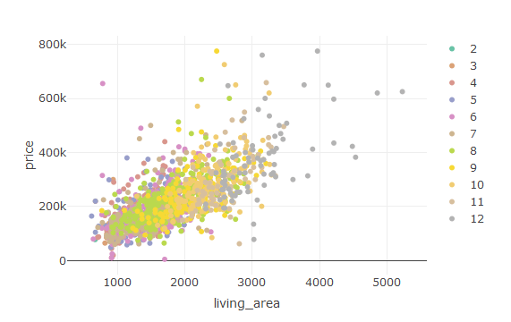

144. How do you list the preloaded datasets in R?
To view a list of preloaded datasets in R, simply type data() into the console and hit enter.
I’m running R version 3.5.1 for Windows on my machine with a standard, default install. The output in RStudio for me looks something like this:
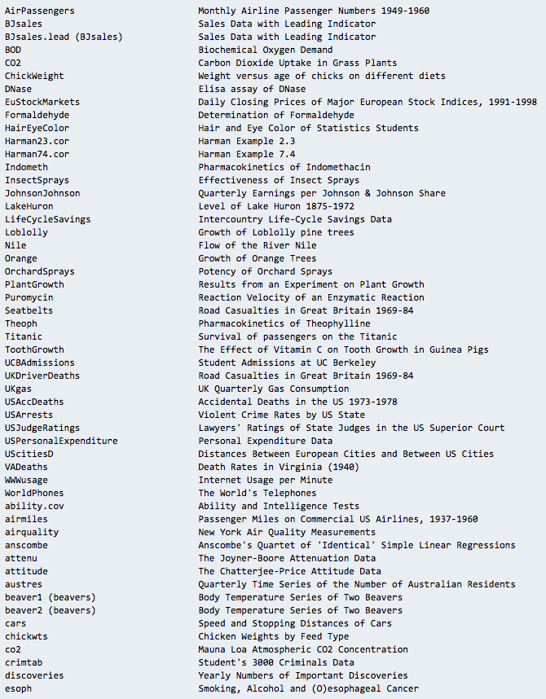
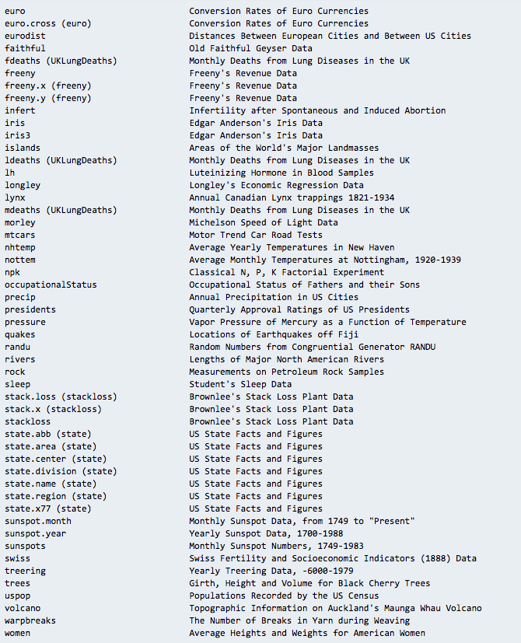

145. When is it appropriate to use the “next” statement in R?
A data scientist will use next to skip an iteration in a loop. As an example:
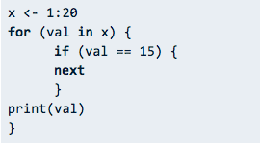
This code iterates through a range of numbers from 1 to 20 and prints the values. I don’t want to print 15, though, so I’ve used the next statement to skip that iteration and move on to other values. The output would print 1-14 and 16-20.

146. How do you assign a variable in R?
Variable assignment in R is a bit different from other languages. Rather than using an = sign, we typically use a less-than sign, < ,followed by a minus, –. An equals sign, =, still works, but there are arguments about its readability in addition to instances where it can actually muck up your code. I suggest you stick with <- for assignment in R, if for no other reason than it’s expected (Google’s R style manual, which is widely used, prohibits = for assignment).
myVar <- 15
print(myVar
Notice the following is also valid:
myVar = 15
print(myVar)
You can also assign variables the other way around in R.
"helloWorld" -> myVar
The string “helloWorld” is now stored in the myVar variable. Note that this would produce an error if we got mixed up and tried to plug an undefined variable object into a string, as in:
myVar -> "helloWorld"
Error: object 'myVar' not found
Scoping of variables is something to consider as well. <<- acts as the “superassignment” operator and is useful for closures. A good example on how to use this can be found on stackoverflow.
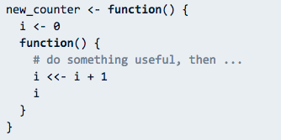

147. What are the different data types/objects in R?
This is another good opportunity to show that you know R, and you’re not winging it. Unlike other object-oriented languages such as C, R doesn’t ask users to declare a data type when assigning a variable. Instead, everything in R correlates to an R data object. When you assign a variable in R, you assign it a data object and that object’s data type determines the data type of the variable. The most commonly used data objects include:
- Vectors
- Matrices
- Lists
- Arrays
- Factors
- Data frames

148 What are the objects you use most frequently?
This question is meant to gather a sense of your experiences in R. Simply think about some recent work you’ve done in R and explain the data objects you use most often. If you use arrays frequently, explain why and how you’ve used them.

149. Why use R?
This is a variant of the “advantages of R” question. Reasons to use R include its open-source nature and the fact that it’s a versatile tool for statistical plotting, analysis, and portrayal. Don’t be afraid to give some personal reasons as well. Maybe you simply love the assignment operator in R or feel that it’s more elegant than other languages—but always remember to explicate. You should be answering follow-up questions before they’re even asked.

150. Can you create a decision tree in R?
A decision tree is a familiar graph for data scientists. It represents choices and results through the graphical form of a tree. To keep things simple, let’s just go over the basics.
Install the party package to get started with making the tree.
install.packages("party")
This gives you access to a fancy new function: ctree(), and, at its most basic, this is all we need to create a tree. First, let’s grab some data from our package; make sure the package is loaded.
library(party)
Now we have access to some new data sets. Part of the strucchange package that bundles with party includes data on youth homicides in Boston called BostonHomicide. Let’s use that one. You can print the data to the screen if you like.
print(BostonHomicide)
Now we’ll create the tree. The usage of ctree() goes something like this:
ctree(formula,dataset)
We’ve got our data set. I’ll assign it to a variable for simplicity.
inputData <- BostonHomicides
Now we can determine our formula and create the tree.
treeAnalysis <- ctree(year~population+homicides+unemploy, data = inputData)
Let’s plot it!
plot(treeAnalysis)
Here’s the result I got.
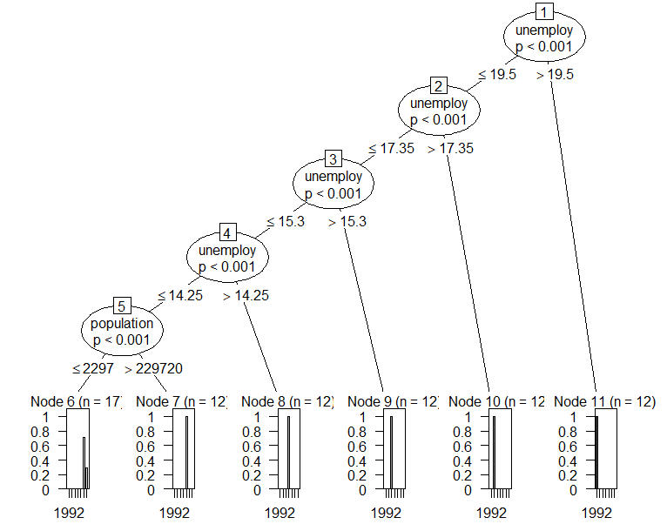

151. A csv file consists of missing values that are represented by hashtags (“#”) and ampersands (“&”). How can you read this type of a csv file in R?
We can read this type of data with the following line of code –
- csv2(‘data-file.csv’,header=FALSE,sep=’,’,na.strings=c(‘#’,’&’))

152. Suppose that you have an array consisting of several objects. This object is of the type string. Let this string be “TotalDataScience”. Now, you want to find the location of this string in the character array ‘arr’. How will you carry this out?
which( arr == “TotalDataScience”)

153. You are solving a data science problem that is ridden with many missing values. You want to clean the data before fitting your model. What would you do to replace these missing values? Develop your own function.
Let’s take this vector:
- arr<-c(1,2,4,NA,NA,11,NA,10)
- Now, let’s write the function to impute the values:
- missing_mean <- function(arr){
- ifelse(is.na(arr),mean(arr,na.rm = T),arr)

154. What Is ‘training Set’ and ‘test Set’ in a Machine Learning Model? How Much Data Will You Allocate for Your Training, Validation, and Test Sets?
There is a three-step process followed to create a model:
- Train the model
- Test the model
- Deploy the model
Training Set | Test Set
The training set is examples given to the model to analyze and learn70% of the total data is typically taken as the training datasetThis is labeled data used to train the model | The test set is used to test the accuracy of the hypothesis generated by the modelRemaining 30% is taken as testing datasetWe test without labeled data and then verify results with labels

155. How Do You Handle Missing or Corrupted Data in a Dataset?
One of the easiest ways to handle missing or corrupted data is to drop those rows or columns or replace them entirely with some other value.
There are two useful methods in Pandas:
- IsNull() and dropna() will help to find the columns/rows with missing data and drop them
- Fillna() will replace the wrong values with a placeholder value

156. How Is Amazon Able to Recommend Other Things to Buy? How Does the Recommendation Engine Work?
Once a user buys something from Amazon, Amazon stores that purchase data for future reference and finds products that are most likely also to be bought, it is possible because of the Association algorithm, which can identify patterns in a given dataset.

157. How Do You Design an Email Spam Filter?
Building a spam filter involves the following process:
- The email spam filter will be fed with thousands of emails
- Each of these emails already has a label: ‘spam’ or ‘not spam.’
- The supervised machine learning algorithm will then determine which type of emails are being marked as spam based on spam words like the lottery, free offer, no money, full refund, etc.
- The next time an email is about to hit your inbox, the spam filter will use statistical analysis and algorithms like Decision Trees and SVM to determine how likely the email is spam
- If the likelihood is high, it will label it as spam, and the email won’t hit your inbox
- Based on the accuracy of each model, we will use the algorithm with the highest accuracy after testing all the models

158. What are the three stages to build the hypotheses or model in machine learning?
a) Model building
b) Model testing
c) Applying the model

159. What is the standard approach to supervised learning?
The standard approach to supervised learning is to split the set of example into the training set and the test.

160. What Is Data Normalization, and Why Do We Need It?
The process of standardizing and reforming data is called “Data Normalization.” It’s a pre-processing step to eliminate data redundancy. Often, data comes in, and you get the same information in different formats. In these cases, you should rescale values to fit into a particular range, achieving better convergence.

161. What is an auto-encoder?
Answer:
An autoencoder is an autonomous Machine learning algorithm that uses the backpropagation principle, where the target values are set to be equal to the inputs provided. Internally, it has a hidden layer that describes a code used to represent the input.
Some Key Facts about the autoencoder are as follows:-
•It is an unsupervised ML algorithm similar to Principal Component Analysis
•It minimizes the same objective function as Principal Component Analysis
•It is a neural network
•The neural network’s target output is its input

162. What are the best practices for data cleaning?
Ans. There are 5 basic best practices for data cleaning:
- Make a data cleaning plan by understanding where the common errors take place and keep communications open.
- Standardise the data at the point of entry. This way it is less chaotic and you will be able to ensure that all information is standardised, leading to fewer errors on entry.
- Focus on the accuracy of the data. Maintain the value types of data, provide mandatory constraints and set cross-field validation.
- Identify and remove duplicates before working with the data. This will lead to an effective data analysis process.
- Create a set of utility tools/functions/scripts to handle common data cleaning tasks.

163. What are the data validation methods used in data analytics?
Ans. The various types of data validation methods used are:
- Field Level Validation – validation is done in each field as the user enters the data to avoid errors caused by human interaction.
- Form Level Validation – In this method, validation is done once the user completes the form before a save of the information is needed.
- Data Saving Validation – This type of validation is performed during the saving process of the actual file or database record. This is usually done when there are multiple data entry forms.
- Search Criteria Validation – This type of validation is relevant to the user to match what the user is looking for to a certain degree. It is to ensure that the results are actually returned.

164. How often should a data model be retained?
Ans. A good data analyst would be able to understand the market dynamics and act accordingly to retain a working data model so as to adjust to the new environment

165. Name the best tools used for data analysis.
A question on the most used tool is something you’ll mostly find in any data analytics interview questions.
The most useful tools for data analysis are:
Tableau
Google Fusion Tables
Google Search Operators
KNIME
RapidMiner
Solver
OpenRefine
NodeXL
io

166. Define “Collaborative Filtering”.
Collaborative filtering is an algorithm that creates a recommendation system based on the behavioural data of a user. For instance, online shopping sites usually compile a list of items under “recommended for you” based on your browsing history and previous purchases. The crucial components of this algorithm include users, objects, and their interest.

167. How should you tackle multi-source problems?
To tackle multi-source problems, you need to:
- Identify similar data records and combine them into one record that will contain all the useful attributes, minus the redundancy.
- Facilitate schema integration through schema restructuring.
With that, we come to the end of our list of data analyst interview questions. Although these data analyst interview questions are selected from a vast pool of probable questions, these are the ones you are most likely to face if you’re an aspiring data analyst. These questions set the base for any data analyst interview, and knowing the answers to them is sure to take you a long way!

168. What do data analysts do?
This question is basic but serves an essential function. It weeds out the candidates who lack a rudimentary understanding of data analysis. It also lets you compare how well various candidates understand data analysis.
What to look for in an answer:
- Coverage of each step
- Mention of soft skills, such as communication
- Discussion of how data analysts benefit a company
Example: “In general, data analysts collect, run and crunch data for insight that helps their company make good decisions. They look for correlations and must communicate their results well. Part of the job is also using the data to spot opportunities for preventative measures. That requires critical thinking and creativity.”

169. Which data analysis software are you well-versed in?
This question lets you assess if candidates have the hard skills you need and can tell you what areas they might need training in. It is also another way to ensure basic competency.
What to look for in an answer:
- Software the job ad emphasized
- Experience with the software
- Ability to speak with familiarity
Example: “I have a breadth of software experience. For example, at my current employer, I do a lot of ELKI data management and data mining algorithms. I can also create databases in Access and make tables in Excel.”

170. What is your process when you start a new project?
This question lets you measure candidates’ organizational skills and how well they anticipate. It also gives you an opportunity to see if candidates’ leadership or work styles are compatible with your company culture.
What to look for in an answer:
- Clear steps
- Deliberate process
- Consideration of deadline
Example: “My first step is to take some time to look over the project so that I can define the objective or problem. If I’m having a hard time figuring that part out, I reach out to the client. Next, I feel out the data to see what’s there, how reliable it is and where it comes from. I think about what could be the best way to model it and whether the project deadline seems to work.”
REFERECES
Credit goes to:
- https://www.dezyre.com/
- edureka.com
- https://www.indeed.com/
- simplilearn.com
- springboard.com
More will be added soon. Stay in touch.
If you want to add , send it to support@totaldatascience.com
We will be glad to share your knowlegde as well.
Send any queries to support@totaldatascience.com

Products from Amazon.in
500 Most Important Data Science Interview Questions and Answers: Crack That Next Interview With Higher Salary In Less Preparation Time
Price: Check on Amazon
100 Questions to Crack Data Science Interview
Price: Check on Amazon
- -2%
Heard In Data Science Interviews: Over 650 Most Commonly Asked Interview Questions & Answers
Price: INR 3,573.00

Was: INR 3,638.00

- -23%
Data Structure and Algorithmic Thinking with Python
Price: INR 498.00

Was: INR 650.00

What do they ask in top Data Science Interviews: 5 Complete Data Science Real Interviews Q and A
Price: Check on Amazon
- -10%
Python Interview Questions -Taming The Python: 1
Price: INR 267.00

Was: INR 297.00

- 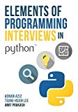-6%
Elements of Programming Interviews in Python: The Insiders’ Guide
Price: INR 2,811.00

Was: INR 2,999.00

- 
1000 Most Important Python Interview Questions and Answers: Crack That Next Interview With Higher Salary In Less Preparation Time
Price: Check on Amazon
‹›

BLOG
- 

How to land a Data Scientist…
December 5, 2019
- 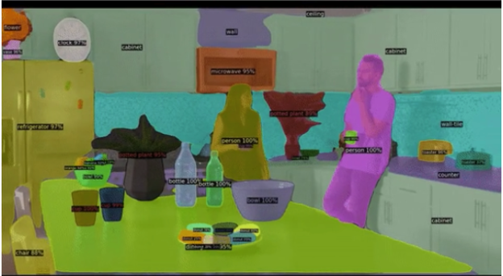

How Facebook’s AI looks for bad…
November 30, 2019
- 

How To Learn ALL The Coursera…
November 24, 2019
- 

Data Science Masters/PH.D. Degree Scholarships
November 10, 2019
- 

Data Science Projects: How to Decide…
October 19, 2019
- 

What Data Scientists Really Do, According…
October 16, 2019
- 

What Great Data Analysts Do and…
October 16, 2019
- 

Will artificial intelligence take over from…
October 14, 2019
- 

McKinsey & Co. Keeps Hiring Data…
October 11, 2019
- 

12 Great Python Resources for Aspiring…
October 8, 2019

MEMBERS
Newest | Active | Popular
- 
brightkyeremeh1
- 
mohamed
NAVANATH
Abdelwaheb
- 
Joel
- 
mrbriit
Hitesh
Omar
- 
Chinmaye
Hoang
MORE
© 2019 - Total datascience

